Lightmongers fill Watermen’s Hall with new members and their guests
With Tallow Chandlers’ Hall undergoing renovation, the Court held its 213th meeting at the historic Watermen’s Hall — home of the Company of Watermen and Lightermen of the City of London.
September 17th was a busy evening for the Master with eight new members admitted as well as an honorary freeman and three Liverymen clothed at court.
The Court extended a warm welcome to the following new members:
Christopher Carr – Senior Specification Manager – Middle East – Zumtobel Group
Simon Lyon – Joint Managing Director, Lightgraphix Ltd
Max Thorpe – Group Innovation Manager, F. W. Thorpe Plc
Tim Den Hertog – Project and Contracts Manager, Drax 360
Simon Goodwin – Managing Director, Goodelectrics Ltd
Stuart Smith – Director at Stromtechs Ltd and Past President of ECA
Tim Lloyd – Director at Alphalite Controls Ltd
Darren Smith – Specification Leader at Signify
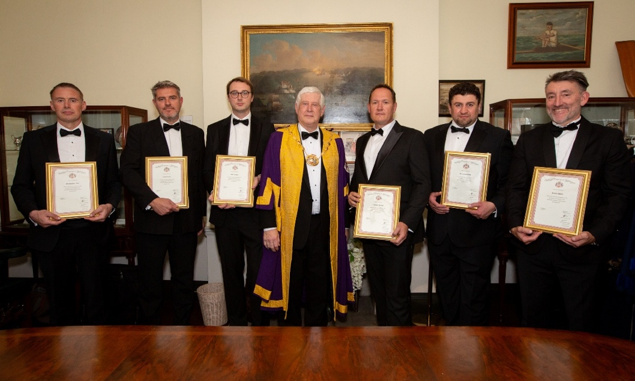
L-R Chris Carr, Simon Lyon, Max Thorpe, the Master, Tim Den Hertog, Simon Goodwin, Stuart Smith
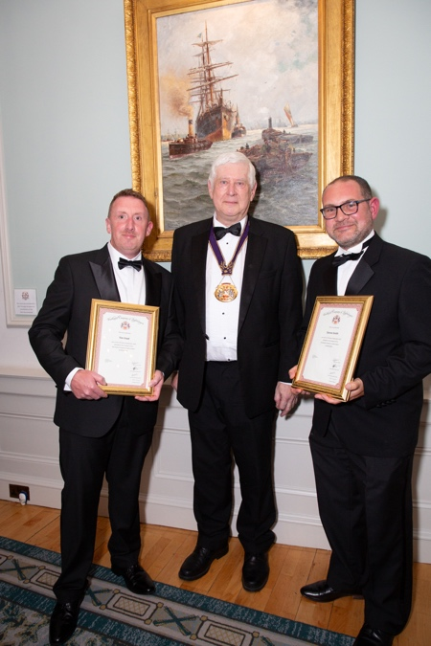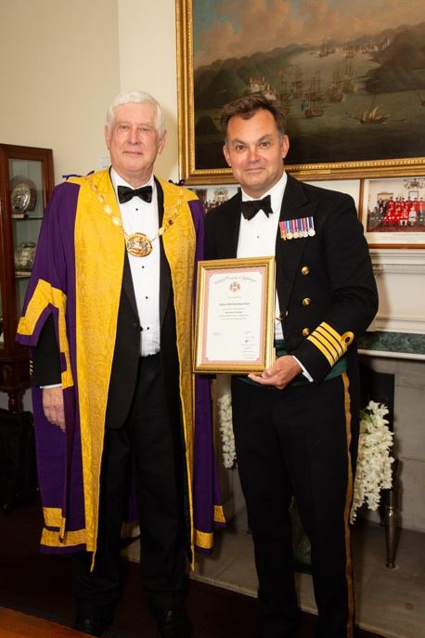
Tim Lloyd, the Master, Darren Smith. The Master and Captain Will King
The Court was delighted that three Freemen of the Company progressed to full membership by becoming Liverymen and thus able to take a fuller part in both the Company and the City of London Livery movement.
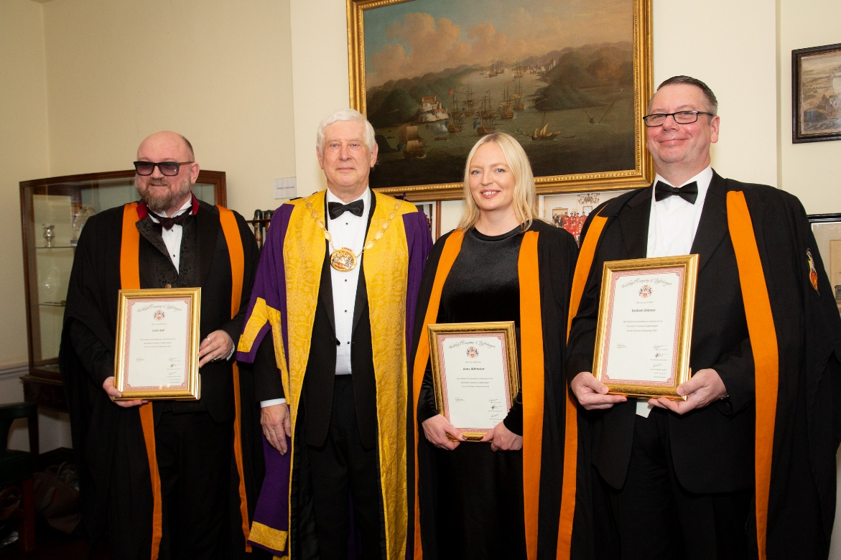
New Liverymen with the Master, Colin Ball, the Master, Anna Whittaker, Graham Skinner.

The Court meeting was followed by a dinner attended by many distinguished City guests including, special guest, Keith Bottomley, Sheriff Elect and Deputy who entertained us with a witty and informative after-dinner speech, delivered with panache.
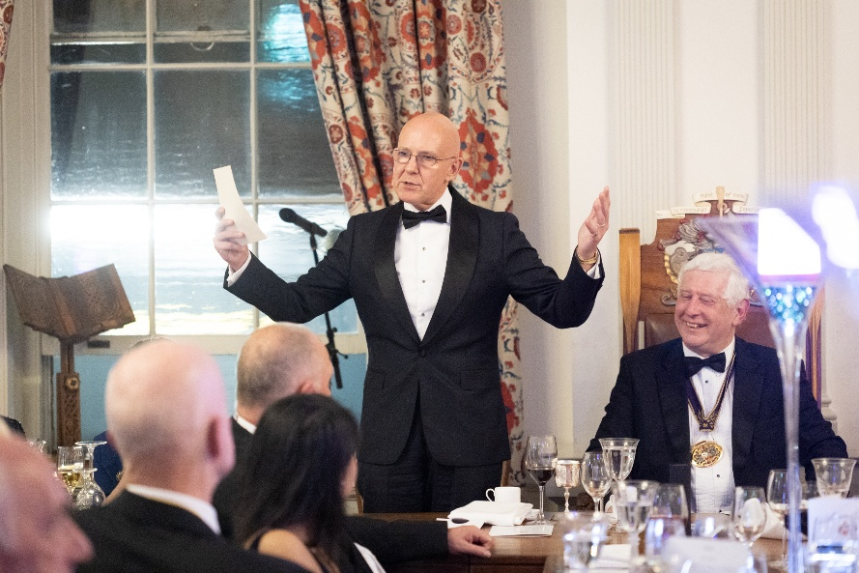
Sheriff Elect Keith Bottomley giving his speech.

A highlight of the evening was the presentation of a donation from the Lightmongers Charitable Trust to our affiliated Sea Cadet unit, TS Wizard, based in Haringey, to support the fantastic work they do in helping young people to develop, learn new skills, etc. The Master presented the donation to the Officer Commanding the Unit, W02 Michael Somogyli, RMR.
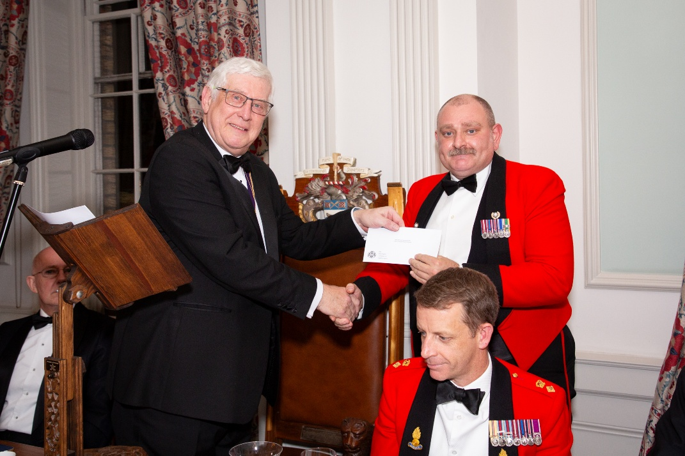
Presentation by the Master of a donation to our affiliated Sea Cadet Unit, TS Wizard.
Please forgive the cliche but the atmosphere during the dinner was truly electric as new members and their guests and sponsors mingled with court members. There is always plenty to talk about given Lightmongers' genuine knowledge of, and passion for, the lighting and electrical industry.
Our next dinner, when our new Master will be installed, will take place back at our home hall, Tallow Chandlers Hall on Friday 7th November.

